

**INTRODUCTION TO DATABASE [K]**

**Final-Term Project**

**Project Name: Bank Management System**

**Submitted by: SHADRIL HASSAN SHIFAT [20-42451-1]**

**Submitted to: RIFAT TASNIM ANANNYA [1801-1845-2]**

**ER Diagram**

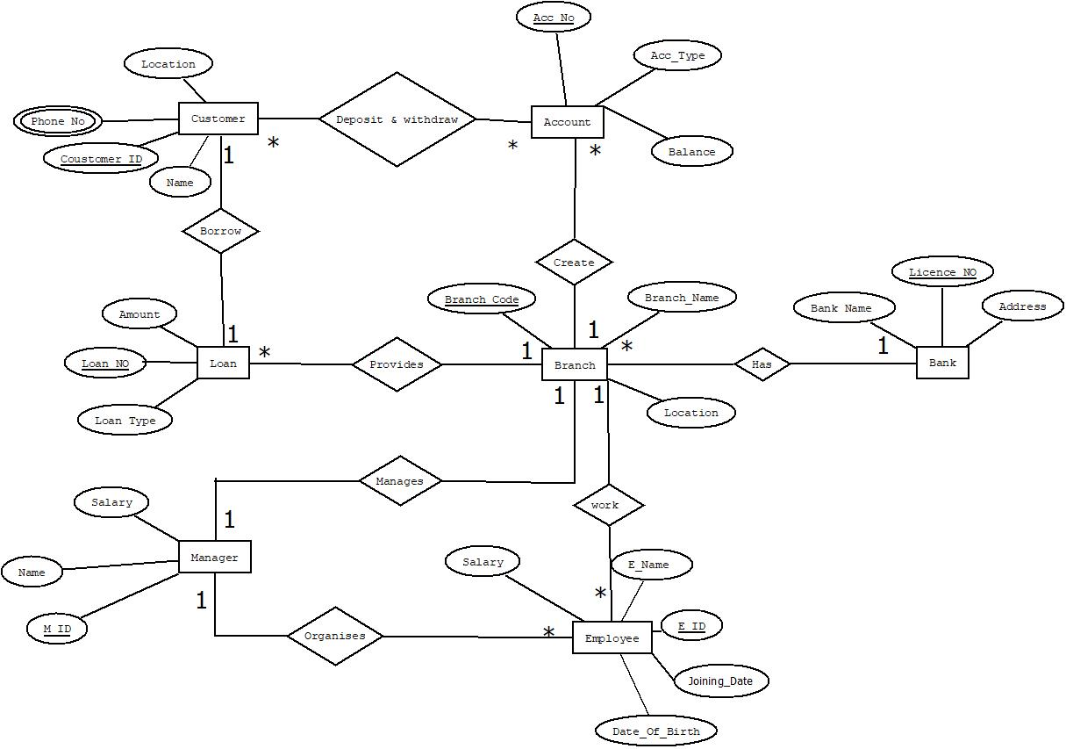

**Scenario**

* Bank are identified by License No and Bank Name, Address are recorded.
* Employees are identified by Employee ID and Employee Name, Date of Birth, Employee Name, Salary, Joining Date, Phone No are recorded. Each Branch has many Employees.
* Customers are identified by Customer ID and Customer Name, Address, Phone No are recorded.
* Each customer has one or more Account / Accounts which is/are identified by Account No and Account Type, Balance are recorded. Many Customers can also deposit and withdraw from many Accounts.
* Accounts must be created on a specific Branch of the Bank. So, there is a many to one relationship between Account and Branch. So, Branch are identified by Branch Code and Branch Name, Location are recorded.
* Each Branch has a Manager (one to one) which is identified by Manager ID and Manager Name, Salary, Phone No , Date of Birth, Hire Date are recorded. Manager organizes many Employees. The cardinality of Manager and Employee is one to many.
* Each Branch provides many Loan (One to many) which is identified by Loan No and Loan Type, Amount are recorded.
* A Customer can borrow Loan (one to one) from a specific Branch. So, there is one to one relationship.

**Normalization:**

**Has**- (li_no, b_name, b_address, br_code, br_name, br_loc)

**1NF**- No multivalued attribute

**2NF**- li_no, b_name, b_address

br_code, br_name, br_loc

**3NF**- No transitive dependency

li_no, b_name, b_address

br_code, br_name, br_loc

**Table for Has-**

1. li_no, b_name, b_address
2. br_code, br_name, br_loc, li_no

**Create**- ( acc_no, acc_type, acc_bal, br_code, br_name, br_loc)

**1NF**- No multivalued attribute

**2NF**- acc_no, acc_type, acc_bal

br_code, br_name, br_loc

**3NF**- No transitive dependency

acc_no, acc_type, acc_bal

br_code, br_name, br_loc

**Table for Create-**

1. acc_no, acc_type, acc_bal, br_code
2. br_code, br_name, br_loc

**Deposit & Withdraw**- ( acc_no, acc_type, acc_bal, c_id, c_name, c_phn, c_loc )

**1NF-** c_phn is a multivalued attribute

**2NF-** acc_no, acc_type, acc_bal

c_id, c_name, c_phn, c_loc

**3NF-** No transitive dependency

acc_no, acc_type, acc_bal

c_id, c_name, c_phn, c_loc

**Table for Deposit & Withdraw-**

1. acc_no, acc_type, acc_bal
2. c_id, c_name, c_loc
3. n_id, acc_no, c_id
4. c_id, c_phn – Composite primary key

**Borrow-** ( c_id, c_name, c_phn, c_loc, loan_no, loan_type, loan_amt)

**1NF-** c_phn is a multivalued attribute

**2NF-** c_id, c_name, c_phn, c_loc

loan_no, loan_type, loan_amt

**3NF-** No transitive dependency

c_id, c_name, c_phn, c_loc

loan_no, loan_type, loan_amt

**Table for Borrow-**

1. c_id, c_name, c_loc, loan_no
2. loan_no, loan_type, loan_amt
3. c_id, c_phn – Composite primary key

**Provides-** ( br_code, br_name, br_loc, loan_no, loan_type, loan_amt)

**1NF-** No multivalued attribute

**2NF-** br_code, br_name, br_loc

loan_no, loan_type, loan_amt

**3NF-** No transitive dependency

br_code, br_name, br_loc

loan_no, loan_type, loan_amt

**Table for Provides-**

1. loan_no, loan_type, loan_amt, br_code
2. br_code, br_name, br_loc

**Manages-** ( m_id, m_name, m_sal, m_dob, m_hiredate, m_phn, br_code, br_name, br_loc)

**1NF-** m_phn is a multivalued attribute

**2NF-** m_id, m_name, m_sal, m_dob, m_hiredate, m_phn

br_code, br_name, br_loc

**3NF-** No transitive dependency

m_id, m_name, m_sal, m_dob, m_hiredate, m_phn

br_code, br_name, br_loc

**Table for Manages-**

1. m_id, m_name, m_sal, m_dob, m_hiredate, br_code
2. br_code, br_name, br_loc
3. m_id, m_phn – Composite primary key

**Organises-** (m_id, m_name, m_sal, m_dob, m_hiredate, m_phn, e_id, e_name, e_sal, e_dob, e_hiredate, e_phn)

**1NF-** m_phn & e_phn are multivalued attributes

**2NF-** m_id, m_name, m_sal, m_dob, m_hiredate, m_phn

e_id, e_name, e_sal, e_dob, e_hiredate, e_phn

**3NF-** No transitive dependency

m_id, m_name, m_sal, m_dob, m_hiredate, m_phn

e_id, e_name, e_sal, e_dob, e_hiredate, e_phn

**Table for Organises-**

1. m_id, m_name, m_sal, m_dob, m_hiredate
2. e_id, e_name, e_sal, e_dob, e_hiredate, m_id
3. m_id, m_phn – Composite primary key
4. e_id, e_phn – Composite primary key

**Work-** ( e_id, e_name, e_sal, e_dob, e_hiredate, e_phn, br_code, br_name, br_loc )

**1NF-** e_phn is a multivalued attribute

**2NF-** br_code, br_name, br_loc

e_id, e_name, e_sal, e_dob, e_hiredate, e_phn

**3NF-** No transitive dependency

br_code, br_name, br_loc

e_id, e_name, e_sal, e_dob, e_hiredate, e_phn

**Table for Work-**

1. br_code, br_name, br_loc
2. e_id, e_name, e_sal, e_dob, e_hiredate, br_code
3. e_id, e_phn – Composite primary key

**Final table list-**

1. li_no, b_name, b_address - bank
2. br_code, br_name, br_loc, li_no - branch
3. acc_no, acc_type, acc_bal, br_code -account
4. n_id, acc_no, c_id -customerinfo
5. c_id, c_phn -customer_phn
6. c_id, c_name, c_loc, loan_no - customer
7. loan_no, loan_type, loan_amt, br_code -loan
8. m_id, m_name, m_sal, m_dob, m_hiredate, br_code - manager
9. m_id, m_phn – manager_phn

10. e_id, e_name, e_sal, e_dob, e_hiredate, m_id, br_code -employee

11. e_id, e_phn - employee_phn

# Table Screenshots-

1. **bank-**

Description-

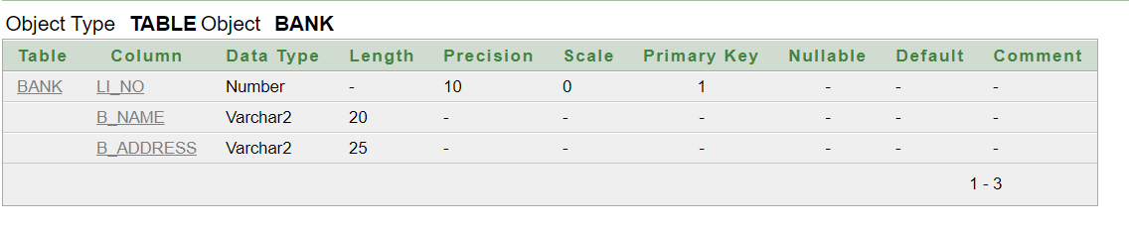

*** not null constraint added in bank_name, b_address

Select * from bank -

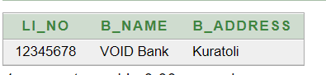

1. **branch-**

Description-

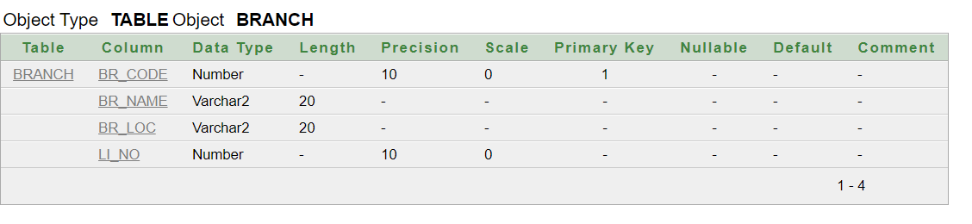

*** not null constraint added in br_name, br_loc, li_no

Select * from branch –

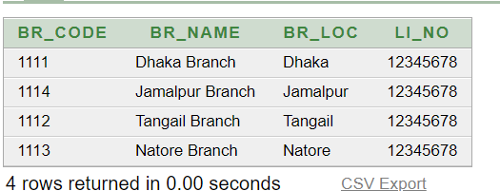

1. **account-**

Description –

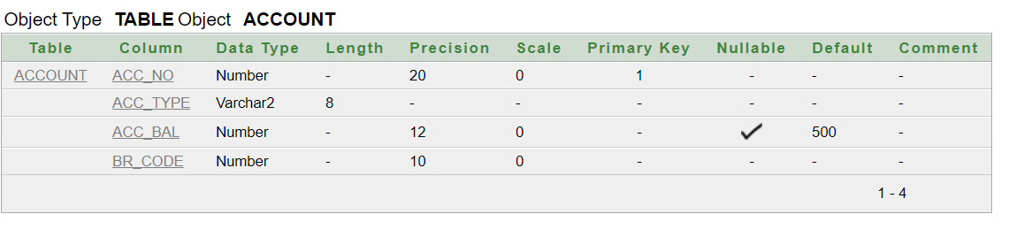

*** default constraint added in acc_bal and not null constraint added in acc_type, br_code

Select * from account –

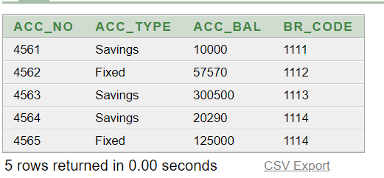

1. **customer-**

Description-

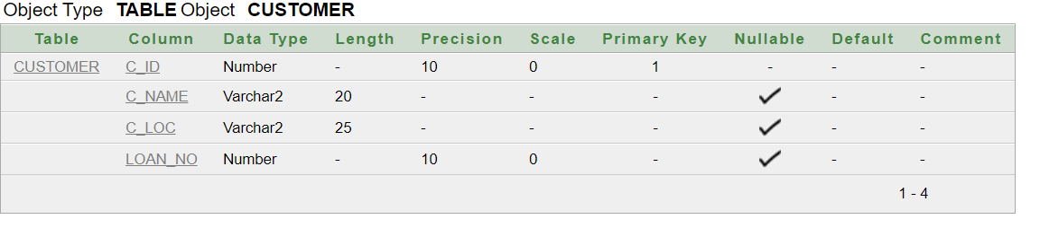

Select * from customer –

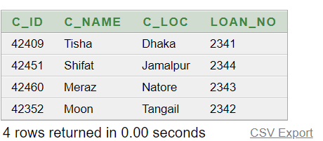

1. **customer_phn –**

Description-

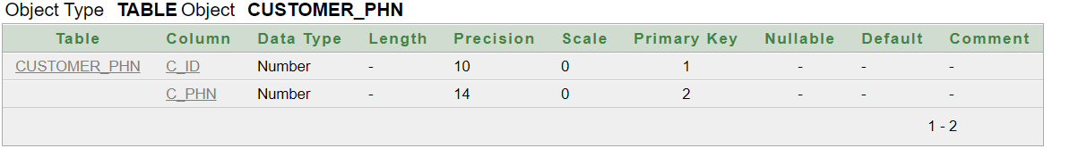

Select * from customer_phn –

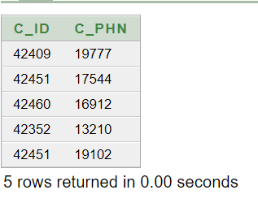

1. **customerinfo-**

Description-

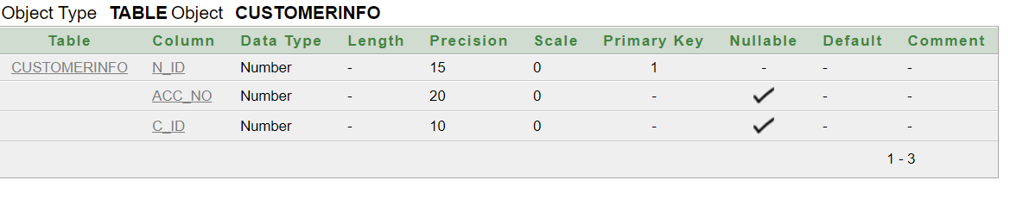

Select * from customerinfo-

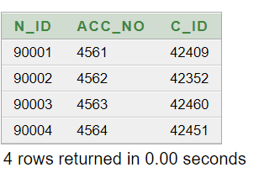

1. **loan-**

Description-

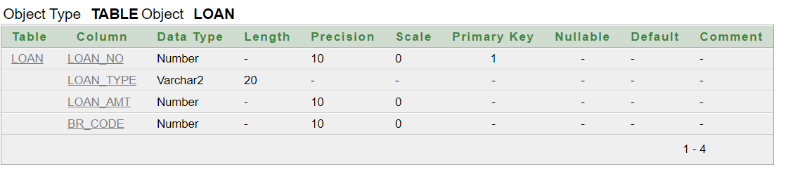

*** not null constraint added in loan_type, loan_amt, br_code

Select * from loan –

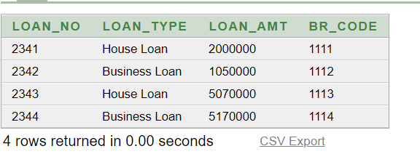

1. **manager –**

Description-

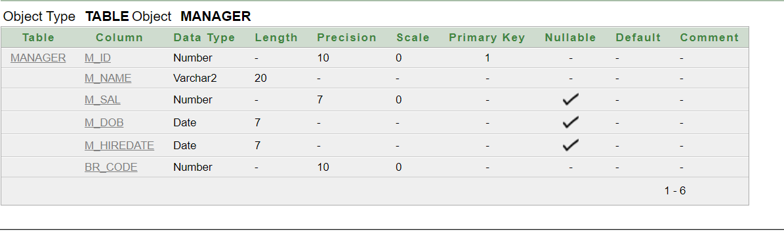

*** not null constraint added in m_name, br_code

Select * from manager –

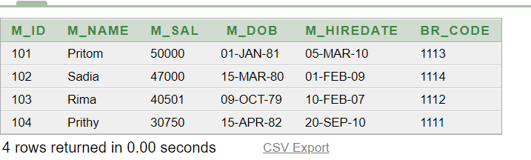

1. **manager_phn –**

Description-

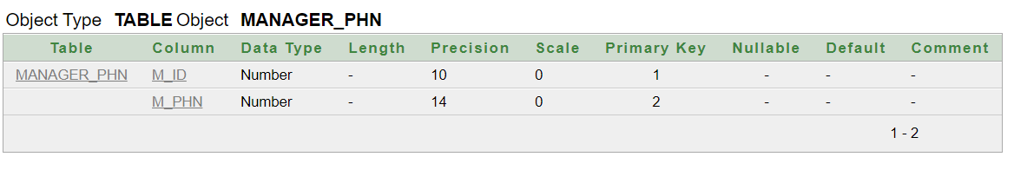

Select * from manager_phn –

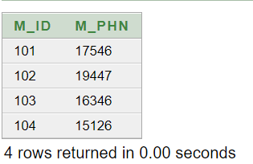

**10. employee-**

Description-

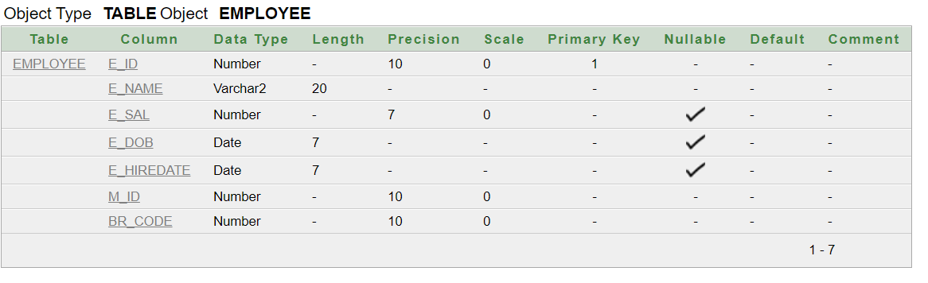

*** not null constraint added in e_name, m_id, br_code

Select * from employee-

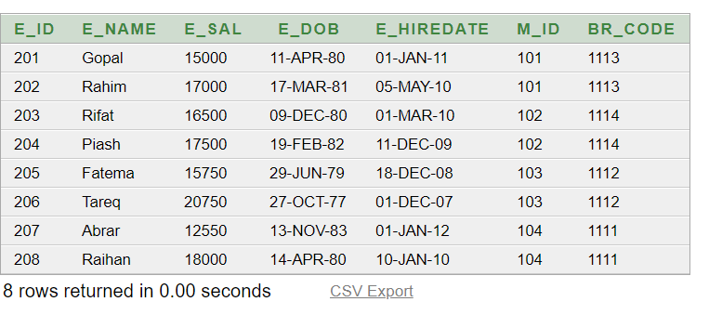

**11. Employee_phn**

Description- 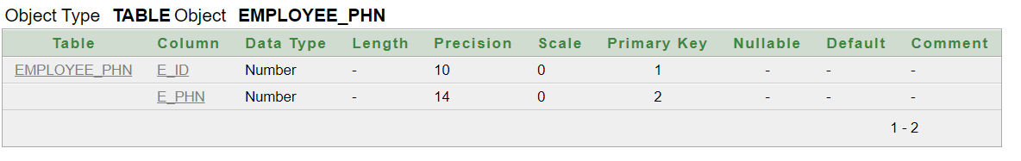

Select * from employee_phn –

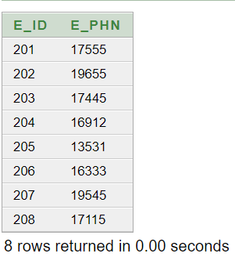

**Questions –**

1. Find nid, account no and account balance of these person who have Savings account. (Join)
2. Find the manager id, manager name and manager dob of that employees who earn more than 17000. (Multiple Row Sub query)
3. Display those employee name, employee id and employee working years (Rounded) as Working Years whose manager get salary more than 39000. (Date, Join, Multiple Row Sub query)
4. Display branch name where loan amount is minimum of Business Loan Type . (Group Function, Sub Query)
5. Create sequence named Bankdata. Increment by 1,Max value 999,starts with 101,no min value,no cycle & no cache.(Sequence)
6. Create a view named CustomerLoanDetails which contains all customer id, customer name, customer location, loan no, loan type, loan amount.(view)
7. Display all the details employee whose name start with ‘R’ or the second letter is ‘a’.(like operator)
8. Display the minimum average salary of employee group by branch code. (group by)
9. Display the phone no of those customer whose name length is 5.(length, sub query)

**10 .** Display all the employees name and hiredate who joined after the manager. (Date, subquery)